10G-SFP-BD23-20
10Gb/s BIDI SFP+ 1270Tx/1330Rx 20km Transceiver
PRODUCT FEATURES
- Up to 11.3Gbps Data Links
- Single Mode LC Receptacle
- Up to 20km transmission on SMF
- Power dissipation<1.2W
- 1270nm DFB laser and PIN receiver
- 2-wire interface with integrated Digital Diagnostic monitoring
- EEPROM with Serial ID Functionality
- Compliant with SFP+ MSA with duplex LC connector
- Single + 3.3V Power Supply and LVTTL Logic
- Case operating temperature: Commercial: 0°C to +70°C
Industrial: -40°C to +85°C
APPLICATIONS
- 10GBASE-BX at 10.3125 Gb/s
- 10GBASE-BX at 9.953 Gb/s
STANDARD
- Compliant with SFF-8472 and SFP+ M.SA
- Compliant to SFP+ SFF-8431 and SFF-8432.
- Compliant to 802.3ae 10GBASE-LR.
- RoHS Compliant.

PRODUCT DESCRIPTION
10G-SFP-BD23-20 is hot pluggable 3.3V Small-Form-Factor transceiver module. It designed expressly for high-speed communication applications that require rates up to 11.3Gbps,it designed to be compliant with SFF-8472 and SFP+ MSA. The module data link up to20km in 9/125um single mode fiber. The optical output can be disabled by a LVTTL logic high-level input of Tx Disable. Tx Fault is provided to indicate that degradation of the laser. Loss of signal (LOS) output is provided to indicate the loss of an input optical signal of receiver or the link status with partner.
ⅠAbsolute Maximum Ratings
Parameter | Symbol | Min. | Typ. | Max. | Unit | Note
Storage Temperature | Ts | -40 | - | 85 | ºC
Storage Ambient Humidity | HA | 5 | - | 95 | %
Operating Relative Humidity | RH | - | - | 85 | %
Power Supply Voltage | VCC | -0.3 | - | 4 | V
Signal Input Voltage |  | Vcc-0.3 | - | Vcc+0.3 | V
Ⅱ Recommended Operating Conditions
Parameter | Symbol | Min. | Typ. | Max. | Unit | Note
Case Operating Temperature | Tcase | 0 | - | 70 | ºC | Without air flow
Power Supply Voltage | VCC | 3.14 | 3.3 | 3.47 | V
Power Supply Current | ICC | - |  | 350 | mA
Data Rate | BR |  | 10.3125 |  | Gbps
Transmission Distance | TD |  | - | 20 | km | Note (1)
Coupled fiber | Single mode fiber |  |  |  |  | ITU-T SMF
Note： Measured with SMF
Ⅲ Optical Characteristics
Parameter | Symbol | Min. | Typ. | Max. | Unit | Note
Transmitter
Average Launched Power | PO | -6 | - | 0 | dBm
Average Launched Power(Laser Off) | Poff | - | - | -30 | dBm | Note (1)
Center Wavelength Range | λC | 1260 | 1270 | 1280 | nm
Side mode suppression ratio | SMSR | 30 | - | - | dB
Spectrum Bandwidth(-20dB) | σ | - | - | 1 | nm
Extinction Ratio | ER | 3.5 |  | - | dB | Note (2)
Output Eye Mask | Compliant with IEEE 0802.3ae |  |  |  |  | Note (2)
Receiver
Input Optical Wavelength | λIN | 1320 | 1330 | 1340 | nm
Receiver Sensitivity | Psen | - | - | -14.4 | dBm | Note (3)
Input Saturation Power (Overload) | PSAT | 0.5 | - | - | dBm | Note (3)
LOS -Assert Power | PA | -30 | - | - | dBm
LOS -Deassert Power | PD | - | - | -17 | dBm
LOS -Hysteresis | PHys | 0.5 | - | 5 | dB
Note:
- The optical power is launched into SMF
- Measured with RPBS 2^31-1 test pattern @10.3125Gbs
- Measured with RPBS 2^31-1 test pattern @10.3125Gbs BER=<10^-12

  - Electrical Interface Characteristics
Parameter | Symbol | Min. | Typ. | Max. | Unit | Note
Total power supply current | Icc | - |  | 350 | mA
Transmitter
Differential Data Input Voltage | VDT | 180 | - | 700 | mVp-p
Differential line input Impedance | RIN | 85 | 100 | 115 | Ohm
Transmitter Fault Output-High | VFaultH | 2.4 | - | Vcc | V
Transmitter Fault Output-Low | VFaultL | -0.3 | - | 0.8 | V
Transmitter Disable Voltage- High | VDisH | 2 | - | Vcc+0.3 | V
Transmitter Disable Voltage- low | VDisL | -0.3 | - | 0.8 | V
Receiver
Differential Data Output Voltage | VDR | 300 | - | 850 | mVp-p
Differential line Output Impedance | ROUT | 80 | 100 | 120 | Ohm
Receiver LOS Pull up Resistor | RLOS | 4.7 | - | 10 | KOhm
Data Output Rise/Fall time | tr/tf |  | - | 38 | ps
LOS Output Voltage-High | VLOSH | 2 | - | Vcc | V
LOS Output Voltage-Low | VLOSL | -0.3 | - | 0.4 | V

  - Pin Description
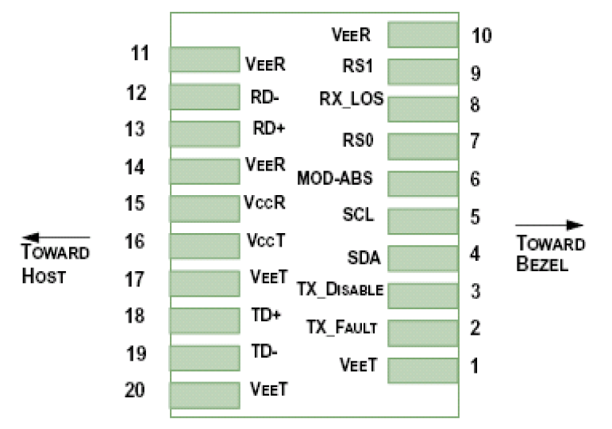

Diagram of Host Board Connector Block Pin Numbers and Name
Pin | Symbol | Name/Description | Ref.
1 | VEET | Transmitter Ground (Common with Receiver Ground) | 1
2 | TFAULT | Transmitter Fault. | 2
3 | TDIS | Transmitter Disable. Laser output disabled on high or open. | 3
4 | SDA | 2-wire Serial Interface Data Line | 4
5 | SCL | 2-wire Serial Interface Clock Line | 4
6 | MOD_ABS | Module Absent. Grounded within the module | 4
7 | RS0 | Rate Select 0 | 5
8 | LOS | Loss of Signal indication. Logic 0 indicates normal operation. | 6
9 | RS1 | No connection required | 1
10 | VEER | Receiver Ground (Common with Transmitter Ground) | 1
11 | VEER | Receiver Ground (Common with Transmitter Ground) | 1
12 | RD- | Receiver Inverted DATA out. AC Coupled
13 | RD+ | Receiver Non-inverted DATA out. AC Coupled
14 | VEER | Receiver Ground (Common with Transmitter Ground) | 1
15 | VCCR | Receiver Power Supply
16 | VCCT | Transmitter Power Supply
17 | VEET | Transmitter Ground (Common with Receiver Ground) | 1
18 | TD+ | Transmitter Non-Inverted DATA in. AC Coupled.
19 | TD- | Transmitter Inverted DATA in. AC Coupled.
20 | VEET | Transmitter Ground (Common with Receiver Ground) | 1
Notes:
- Circuit ground is internally isolated from chassis ground.
- TFAULT is an open collector/drain output, which should be pulled up with a 4.7k – 10k Ohms resistor on the host board if intended for use. Pull up voltage should be between 2.0V to Vcc + 0.3V.A high output indicates a transmitter fault caused by either the TX bias current or the TX output power exceeding the preset alarm thresholds. A low output indicates normal operation. In the low state, the output is pulled to <0.8V.
- Laser output disabled on TDIS >2.0V or open, enabled on TDIS <0.8V.
- Should be pulled up with 4.7kΩ- 10kΩ host board to a voltage between 2.0V and 3.6V. MOD_ABS pulls line low to indicate module is plugged in.
- Internally pulled down per SFF-8431 Rev 4.1.
- LOS is open collector output. It should be pulled up with 4.7kΩ – 10kΩ on host board to a voltage between 2.0V and 3.6V. Logic 0 indicates normal operation; logic 1 indicates loss of signal.

  - Recommended Interface Circuit
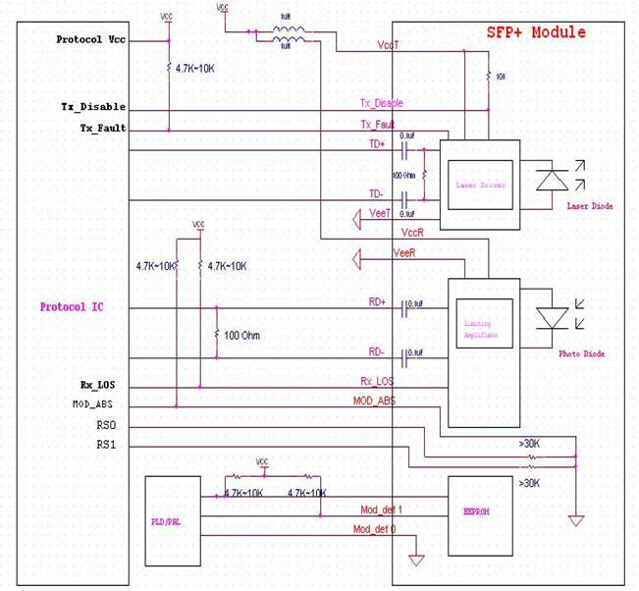
  - Outline Dimensions
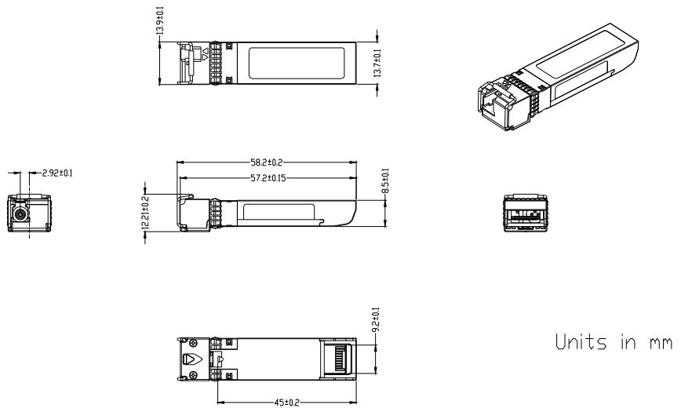
  - Regulatory Compliance
Feature | Reference | Performance
Electrostatic discharge（ESD） | IEC/EN 61000-4-2 | Compatible with standards
Electromagnetic Interference (EMI) | FCC Part 15 Class B EN 55022 Class B (CISPR 22A) | Compatible with standards
Laser Eye Safety | FDA 21CFR 1040.10, 1040.11 IEC/EN 60825-1，2 | Class 1 laser product
Component Recognition | IEC/EN 60950 ，UL | Compatible with standards
ROHS | 2002/95/EC | Compatible with standards
EMC | EN61000-3 | Compatible with standards

